CityMind

An Urban Intelligence System

Phase 1
Problem Analysis & Design Document

Phase 1: Problem Analysis & Design Document

Course: Artificial Intelligence (CS-3001)

Department: Department of Computer Science

Institution: FAST NUCES, Islamabad

Group Details

Section: CS-D

Group ID: i240838_i240839_i240726
Name | ID
Zainab Nisar | i240838
Sabia Munir | i240839
Umaima Hayat | i240726

1. Executive Summary
CityMind is an intelligent decision support system designed to help city authorities manage a complex and growing urban environment. The system represents the entire city using a shared graph, where nodes represent locations and edges represent roads.
The system is designed in a modular way, with multiple components handling different tasks such as city planning, road network design, emergency response management, route finding, and risk analysis. Each module operates on the same graph structure and can apply suitable techniques or algorithms depending on the problem requirements.
A central graph is used as the main data structure of the system. All modules read from and update this graph. Any changes, such as updates in road conditions, risk levels, or resource placement, are reflected across the system so that all components stay consistent and up to date.
This document describes the system design, including the problem understanding, overall architecture, graph structure, module responsibilities, user interface idea, and division of work among team members.

The City Model
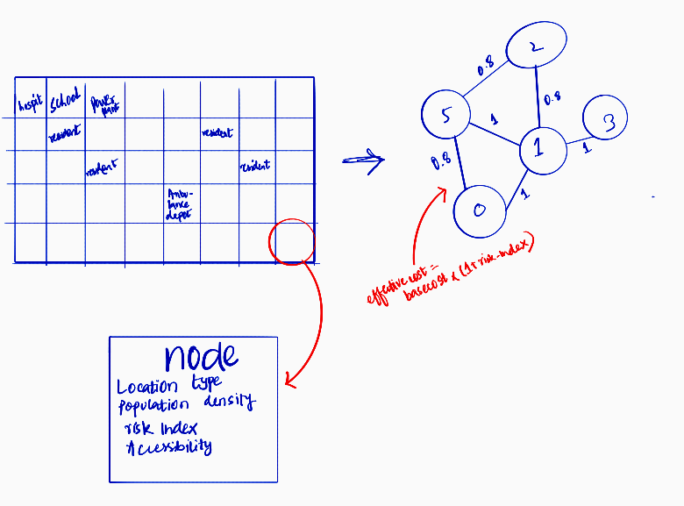

The city is represented as a weighted undirected graph G = (V, E). Each vertex v ∈ V is a grid cell (location) and each edge e ∈ E is a road between two adjacent cells. The graph is the shared among all modules so that no module may maintain its own separate copy.

Node Attributes
Attribute | Type | Description
location_type | Enum | Residential, Hospital, School, Industrial, PowerPlant, AmbulanceDepot
population_density | Float | Number of people occupying this cell during normal operation
risk_index | Float (0-1) | Dynamically updated; fed back from Challenge 5 output
is_accessible | Boolean | False if isolated by flooding

EdgeData Fields
Field | Type | Updated By
base_cost | float | Challenge 2 (MST)
blocked | bool | Challenge 4 (flood events)
risk_index | float | Risk value from challenge 5 affecting travel difficulty
effective_cost | float | Runtime cost= base_cost *(1+risk_index) or inf if blocked

2.3 Grid Size Decision
We will use a 10×10 grid (100 nodes). This is large enough to make all five problems non-trivial, yet small enough that our algorithms run in real time during the 20-step simulation.

City Layout Planning

We are given an empty 10×10 grid and need to place six different types of locations on it while following certain rules. In simple terms, this is like solving a puzzle where every cell must be assigned a valid type without breaking any constraints.

The goal is to find a layout where all rules are satisfied at the same time. If that’s not possible, the system should figure out which rule is causing the issue and slightly relax it to still produce a workable layout.

Constraints

The layout must satisfy the following constraints:

Separation: Industrial areas cannot be placed next to hospitals or schools.

Hospital Access: Every residential area must have a hospital within 3 hops.

Power Supply: Every power plant must be within 2 hops of an industrial area.

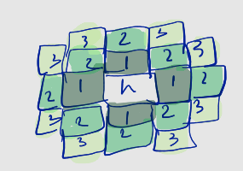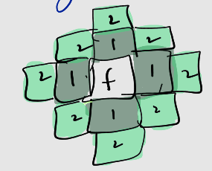

Chosen Algorithm

We use Backtracking, improved with Forward Checking and the MRV (Minimum Remaining Values) heuristic.

Backtracking tries placing locations one by one and goes back if a rule is violated.

Forward Checking helps us avoid problems early by removing invalid options for nearby cells right after each placement.

MRV heuristic makes the process smarter by always picking the cell with the fewest remaining options, so difficult decisions are handled first.

Together, this makes the solution faster and avoids unnecessary work

Alternative Considered

We also considered Random Restart Hill Climbing, where we start with a random layout and keep improving it. However, we are rejecting it because it does not guarantee a solution. It can get stuck or keep trying without success, even if a valid layout exists. Backtracking is better because it is complete, meaning it will find a solution if one exists.

Handling Infeasibility

If no valid layout is found:

We temporarily remove one constraint at a time to see which one is causing the issue

We slightly relax that constraint (for example, increasing distance limits)

We run the algorithm again

We log what change was made

This ensures the system still produces a practical solution instead of failing completely.

Primary Entity Designation

After the layout is complete:

The Primary Hospital is chosen as the one surrounded by the highest nearby population (within 2 hops)

The Primary Ambulance Depot is the closest depot to that hospital

These are calculated once and stored for later use.

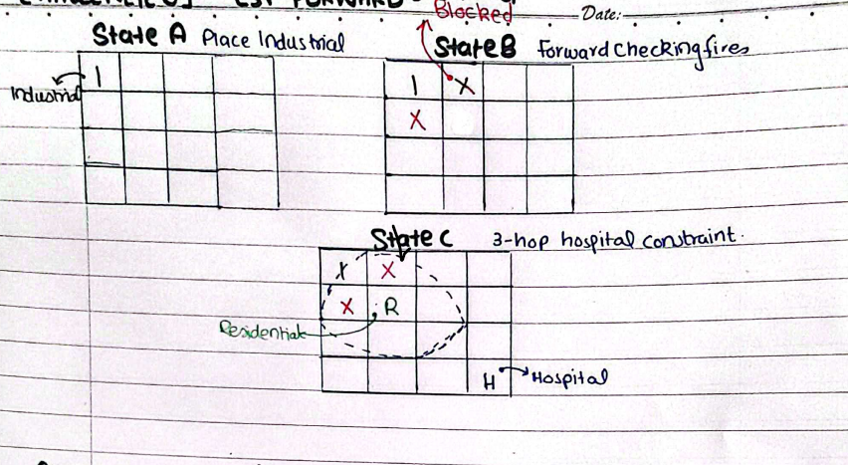



Road Network Optimization

After the city layout is done, we need to connect all locations with roads. The goal is to use the least amount of road possible so construction cost stays low. But there is one rule we cannot ignore that the Primary Hospital and the Ambulance Depot must always have two separate paths between them. These paths cannot share any road. If one road gets flooded, the other path must still work completely on its own. A basic minimum spanning tree only gives one path between any two nodes, so we need an extra step on top of it to satisfy this safety rule.
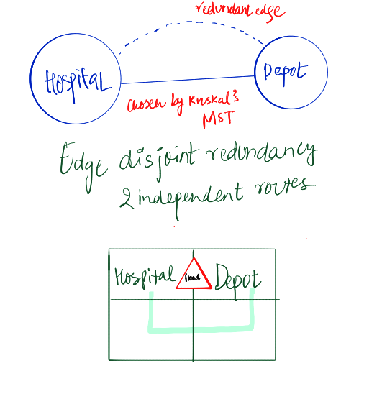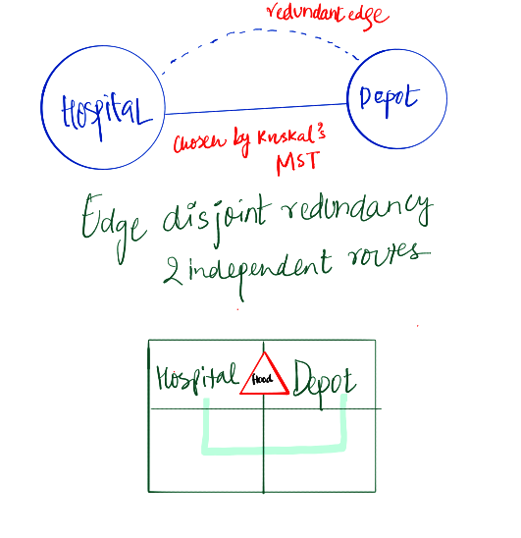

4.2:Comparison with other Algorithms:

We went through all the algorithms we have studied and checked if any of them could solve this problem. None of them could, and here is why:

Algorithm | The Problem with it
BFS | Ignores edge costs, treats all roads equally, cannot optimize construction cost
UCS | Finds shortest path between two nodes only, not a full city-wide network
A* | Requires a goal node and heuristic, not applicable for full network design
Dijkstra | Solves shortest paths from one source, does not decide which roads to build
Prim’s MST | Valid solution, but less flexible than Kruskal for adding redundancy step

Chosen Algorithm: Kruskal's MST + Redundancy Step

Kruskal builds the cheapest possible connected road network. It works like this:

Write down every possible road in the city along with its cost

Sort them from cheapest to most expensive

Go through the list and add each road, but skip any road that would create a loop since loops mean redundant roads which cost extra for no benefit

Stop once every location is connected

After this we check if the Hospital and Depot already have two separate paths. If yes, we are done. If not, we find the single cheapest road not already on the Hospital-Depot path that creates a second route and add it. That one extra road is the only place we go above minimum cost, and it is specifically for the safety rule.

handling Floods

When a road floods, we mark it as blocked in the shared city graph immediately. Every part of the system sees this change at the same time. Because we already guaranteed two separate paths between Hospital and Depot, one flood on that corridor always leaves the other path working. If a civilian node becomes completely cut off with no path available at all, the system logs this in the event log and the medical team moves on to the next reachable civilian.
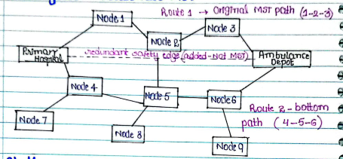



Ambulance Placement

5.1: Our Understanding:

We have 3 ambulances and we need to decide where to park them on the city grid. The goal is not to get a good average response time rather , it is specifically to make sure that even the citizen who is farthest from any ambulance is still as close as possible. We focus on the worst case, not the average.

On a 10x10 grid, choosing 3 positions out of 100 nodes gives like 161,700 possible combinations. For each combination we would need to calculate shortest path distances for every citizen node. We cannot check every possibility in a reasonable time, especially since we need to redo this during the simulation whenever the city changes.

5.2: Comparison with other Algos:
Algorithm | The problem with it
Greedy Placement | Early ambulance positions restrict later choices, leading to poor overall coverage with no backtracking
BFS / Dijkstra's | Only measures distances, does not decide placements; would still behave like greedy selection
Simulated Annealing | Improves one solution over time but can get stuck in local optima since it does not explore multiple candidates at once .

5.3 Chosen Algorithm: Genetic Algorithm

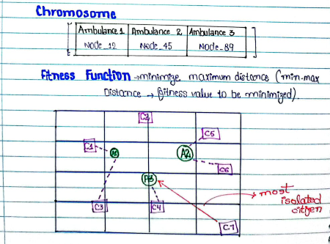

A Genetic Algorithm keeps a whole population of candidate solutions alive at once and improves them over generations by combining good solutions together. This directly solves the problem Simulated Annealing had like instead of one solution getting stuck, we have 80 different solutions exploring different parts of the search space at the same time.

How it works for our problem:

Each solution is just a list of 3 node numbers, the positions of the 3 ambulances

We start with 80 random such solutions

For each solution, we calculate its score: find the farthest citizen from any ambulance. That distance is the score. Lower is better.

We pick the better solutions and combine them to make new ones. For example if solution A has ambulance 1 in a great spot and solution B has ambulance 2 in a great spot, we combine them to get a new solution with both good positions.

Occasionally we randomly move one ambulance to a different node to keep things from going stale

We repeat this for 200 generations or until nothing is improving

Where Ambulances Can Be Placed:

We allow ambulances to be placed at any node in the city not just depots or hospitals. The reason is simple: the best coverage position is whatever node mathematically minimizes the worst-case distance. Sometimes that is a depot, sometimes it is a plain intersection in the middle of a residential area. If we restricted placement to only depots and hospitals we would be artificially limiting the algorithm and guaranteeing a worse result. Our fitness function measures the outcome objectively so we let the algorithm find the true best position without restrictions. This decision is documented here as required by the project.

5.5: Re-optimization During Simulation:

Every 5 simulation steps, Challenge 5 updates the crime risk scores across the city. When this happens, road costs change which means distances change which means the best ambulance positions might change too. We re-run the Genetic Algorithm at these points, but instead of starting from scratch we use the previous best solution as one of the starting chromosomes. This warm start means the algorithm converges faster because it is already starting from a decent position. New placements are written to the shared city graph and logged in the event log.



Emergency Routing Under Dynamic Conditions
In this challenge, a medical team must reach several civilians across a grid. The complication is that the environment is not stable, roads can flood at any moment. As soon as a road becomes blocked, the team must immediately recalculate the shortest remaining path to the next civilian.
Because of this, the routing algorithm must:
- Always guarantee the shortest possible path.
- Must be fast and give a quick response.
- Detect when a civilian becomes completely unreachable.
This is a real-time navigation problem in a changing graph.

Why We Chose A* (A-Star)
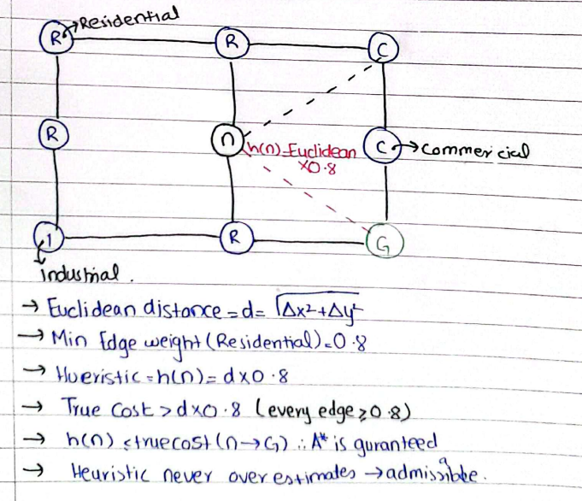
We selected A* because it provides the best balance of optimality, efficiency, and real-time responsiveness for this dynamic scenario

.

What A* Does:
A* is a pathfinding method that predicts which direction is promising. It doesn’t wander around blindly; it makes educated guesses using two values that is g(n) (how far we’ve travelled so far) and( h(n) an estimate of how far we still need to go). The A* uses the sum f(n) = g(n) + h(n) that helps A* prioritize exploring the most promising positions first.
The heuristic that will be used in this is the Euclidean distance. This estimate never overpredicts, making it admissible, which in turn guarantees that A* always finds the shortest true path.

Why A* Works Well in Dynamic Conditions
Whenever a road floods,:
- that edge in the graph is updated to “blocked”.
- A* is restarted from the medical team's current position.
A* handles these repeated recalculations efficiently because its heuristic naturally guides it toward the target instead of expanding the whole grid.

Handling Civilians in Sequence:
The team visits civilians one at a time by always choosing the one that is closest to their current position. For each civilian in this sequence, A* is used to find the shortest path. If A* cannot find a path because flooding has cut off all possible routes, we simply mark that civilian as unreachable and move on to the next one.

Proof of Optimality (Admissibility)
Our heuristic is: h(n) = EuclideanDistance(n, goal) × 0.8
Since the lowest-cost edge is 0.8, this heuristic never overestimates the true cost. This guarantees that A* always returns the true shortest path and replanning remains consistent even when the graph updates.

Why Not Other Algorithms?
- Dijkstra’s Algorithm
This algorithm can find the shortest path correctly, but it does not use any heuristic to guide the search. As a result, it explores many unnecessary nodes
- Breadth-First Search (BFS)
BFS works well only when all roads have equal cost. In our case, roads have different weights and can become blocked, so BFS cannot guarantee the true shortest path.
- Greedy Best-First Search
This method selects paths based only on estimated distance to the goal. While it is fast, it ignores the actual cost travelled, so it may produce suboptimal or incorrect paths.
- Depth-First Search (DFS)
DFS explores paths deeply without considering cost or optimality. It can easily take inefficient routes and is not suitable for shortest-path problems.



Crime Risk Prediction and Integration

This challenge has three tightly coupled steps: unsupervised clustering of neighbourhoods, supervised classification of risk levels, and integration of the predicted risk back into the shared city graph as a cost multiplier. The two learning paradigms are intentionally different: clustering requires no labels (there are none at the start), while classification requires labelled training data (which we generate synthetically).

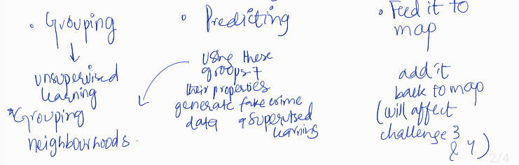

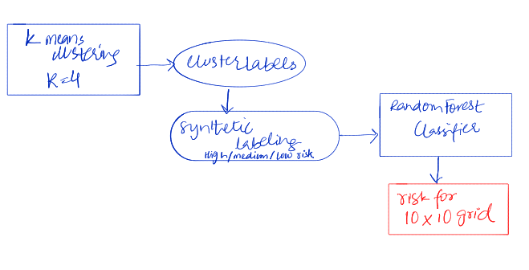

Step 1- Unsupervised Clustering: K-Means
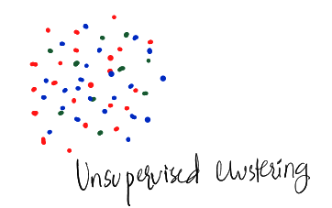
K-Means groups the 100 nodes into k clusters based on two features: population_density and industrial_proximity (shortest-path distance to nearest Industrial node). We choose k = 4 clusters (Low-Density Residential, High-Density Residential, Industrial-Adjacent, and Civic) determined by the elbow method on within-cluster sum of squares.
Why K-Means: It is the canonical unsupervised clustering algorithm, directly covered in the course. It is computationally light (O(n·k·iterations)) and produces interpretable cluster centres. Alternative considered: DBSCAN. Rejected because DBSCAN requires tuning of epsilon and min_samples
Step 2 Supervised Classification: Random Forest
We generate a synthetic crime dataset by assigning an incident_rate to each node using the formula:
incident_rate = (0.4 × normalised_population_density) + (0.35 × (1 / (industrial_proximity + 1))) + (0.25 × cluster_label_encoded) + Gaussian_noise(0, 0.05)
Nodes are labelled High (incident_rate > 0.65), Medium (0.35–0.65), or Low (< 0.35). A Random Forest classifier is trained on these 100 labelled examples using 5-fold cross-validation to verify accuracy before deployment.

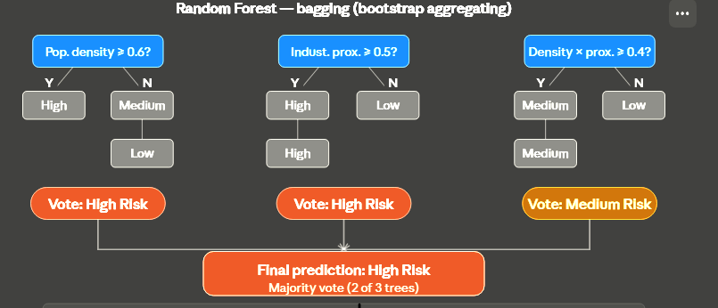
Why Random Forest: Handles small datasets well, resistant to overfitting via bagging, produces feature importance scores that we can present in the UI to justify predictions.
Alternative considered: Decision Tree (single). Rejected because a single tree overfits on 100 examples; Random Forest's ensemble averaging reduces variance significantly.

Step 3- Graph Integration
After prediction, each node's risk_index is set to the model's output: 0.8 for High, 0.4 for Medium, 0.1 for Low. The effective travel cost of any edge (u,v) becomes:
effective_cost(u,v) = base_cost × (1 + (risk_index(u) + risk_index(v)) / 2)
This propagation happens automatically because A* and the GA read effective_cost directly from the shared graph.

9. System Integration and 20-Step Simulation

The Simulation Lifecycle
The CityMind system operates on a discrete-time simulation spanning 20 steps. To ensure consistency, every step follows a strict Execution Pipeline where changes in one module propagate through the shared graph to influence others.
The Step-Wise Sequence:
- Environmental Perturbation: The Flood Event Generator selects 0–2 edges to block (probability 0.15/edge). Blocked edges are immediately flagged in the CityGraph as impassable (Effective_Cost = inf).
- Reactive Re-Routing (Challenge 4): The A* router detects these graph changes. If the medical team's active path is intersected by a flood, a real-time recalculation is triggered from their current node coordinates.
- Intelligence Refresh (Challenge 5): Every 5 simulation steps (5, 10, 15, 20), the machine learning pipeline re-analyzes neighborhood data. New risk scores are written to the nodes, updating the cost multipliers across the grid.
- Strategic Realignment (Challenge 3): Whenever risk scores shift, the Genetic Algorithm re-evaluates ambulance positions. It uses a "warm start" (seeding the population with the previous best solution) to converge quickly on a new optimal layout.
- Telemetry & Rendering: All decisions (e.g., "Edge (x,y) flooded") are serialized to the Live Event Log. The Pygame UI then performs a global redraw of the grid, heatmaps, and coverage overlays.

9.2 Data Flow & Architecture
CityMind utilizes a Centralized Shared State architecture. No module maintains a local copy of the city; they interact with the CityGraph object through specific read/write permissions.
Module | Data Input (Read) | Data Output (Write)
Ch 1: CSP | Constraint Set | Node Types, Population Densities
Ch 2: MST | Node Coordinates | Base Road Costs, Adjacency List
Ch 5: ML | Pop Density, Proximity | Risk Index (0.0 – 1.0) per node
Ch 3: GA | Risk-Adjusted Edge Costs | Global Ambulance Coordinates
Ch 4: A* | Blocked Flags, Edge Costs | Real-time Path Trajectory

Integration Logic: The "Effective Cost"
The core of our integration lies in the Dynamic Weighting Formula. Challenges 3 and 4 do not look at "base costs"; they look at the effective_cost attribute of an edge e(u,v), calculated as:
Effective_Cost = BaseCost * (1 + (Risk_u + Risk_v)/2)
If the blocked flag is True, Effective_Cost returns infinity regardless of risk. This formula ensures that crime risk and environmental hazards are mathematically baked into the system's decision-making.
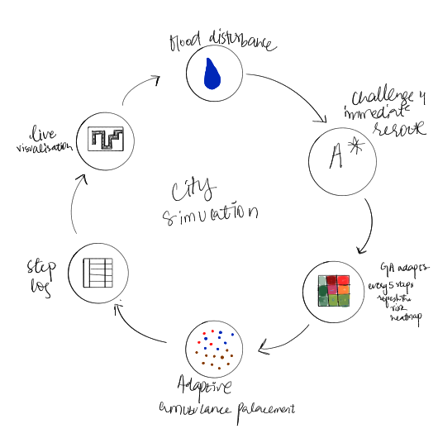

10. User Interface Wireframe & Design

10.1 Technology Choice
The UI will be built using Pygame (Python). Pygame allows us to render the grid in real time, update it per simulation step, and overlay different data layers. It requires no external server and runs as a standalone desktop application.

10.2 Main Layout (Wireframe Description)
The window is divided into three panels:
- LEFT PANEL (600×600 px) — City Grid Canvas. Each of the 100 nodes is drawn as a 56×56 px cell. Colour indicates location type. Overlays are toggled by the control panel
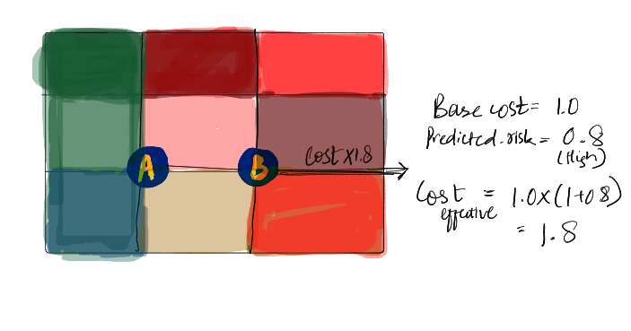
RIGHT PANEL (300×600 px) — Control Panel. Contains toggle buttons: [Road Network], [Ambulance Coverage], [Crime Heatmap]. Also shows current simulation step and a Run/Pause button.
- BOTTOM PANEL (900×200 px) — Live Event Log. Scrollable text area showing timestamped events, e.g. 'Step 7: Edge (34,35) flooded. A* rerouted team via node 45. New cost: 3.2'.

ROUGH UI SKETCH\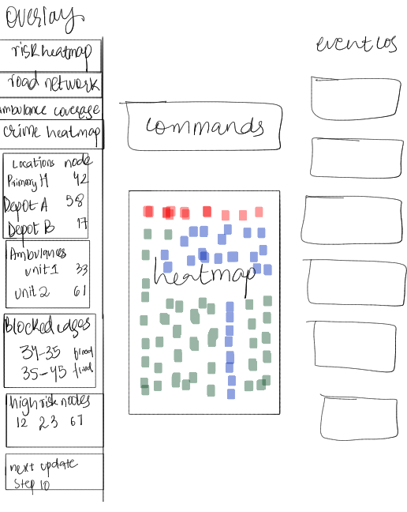
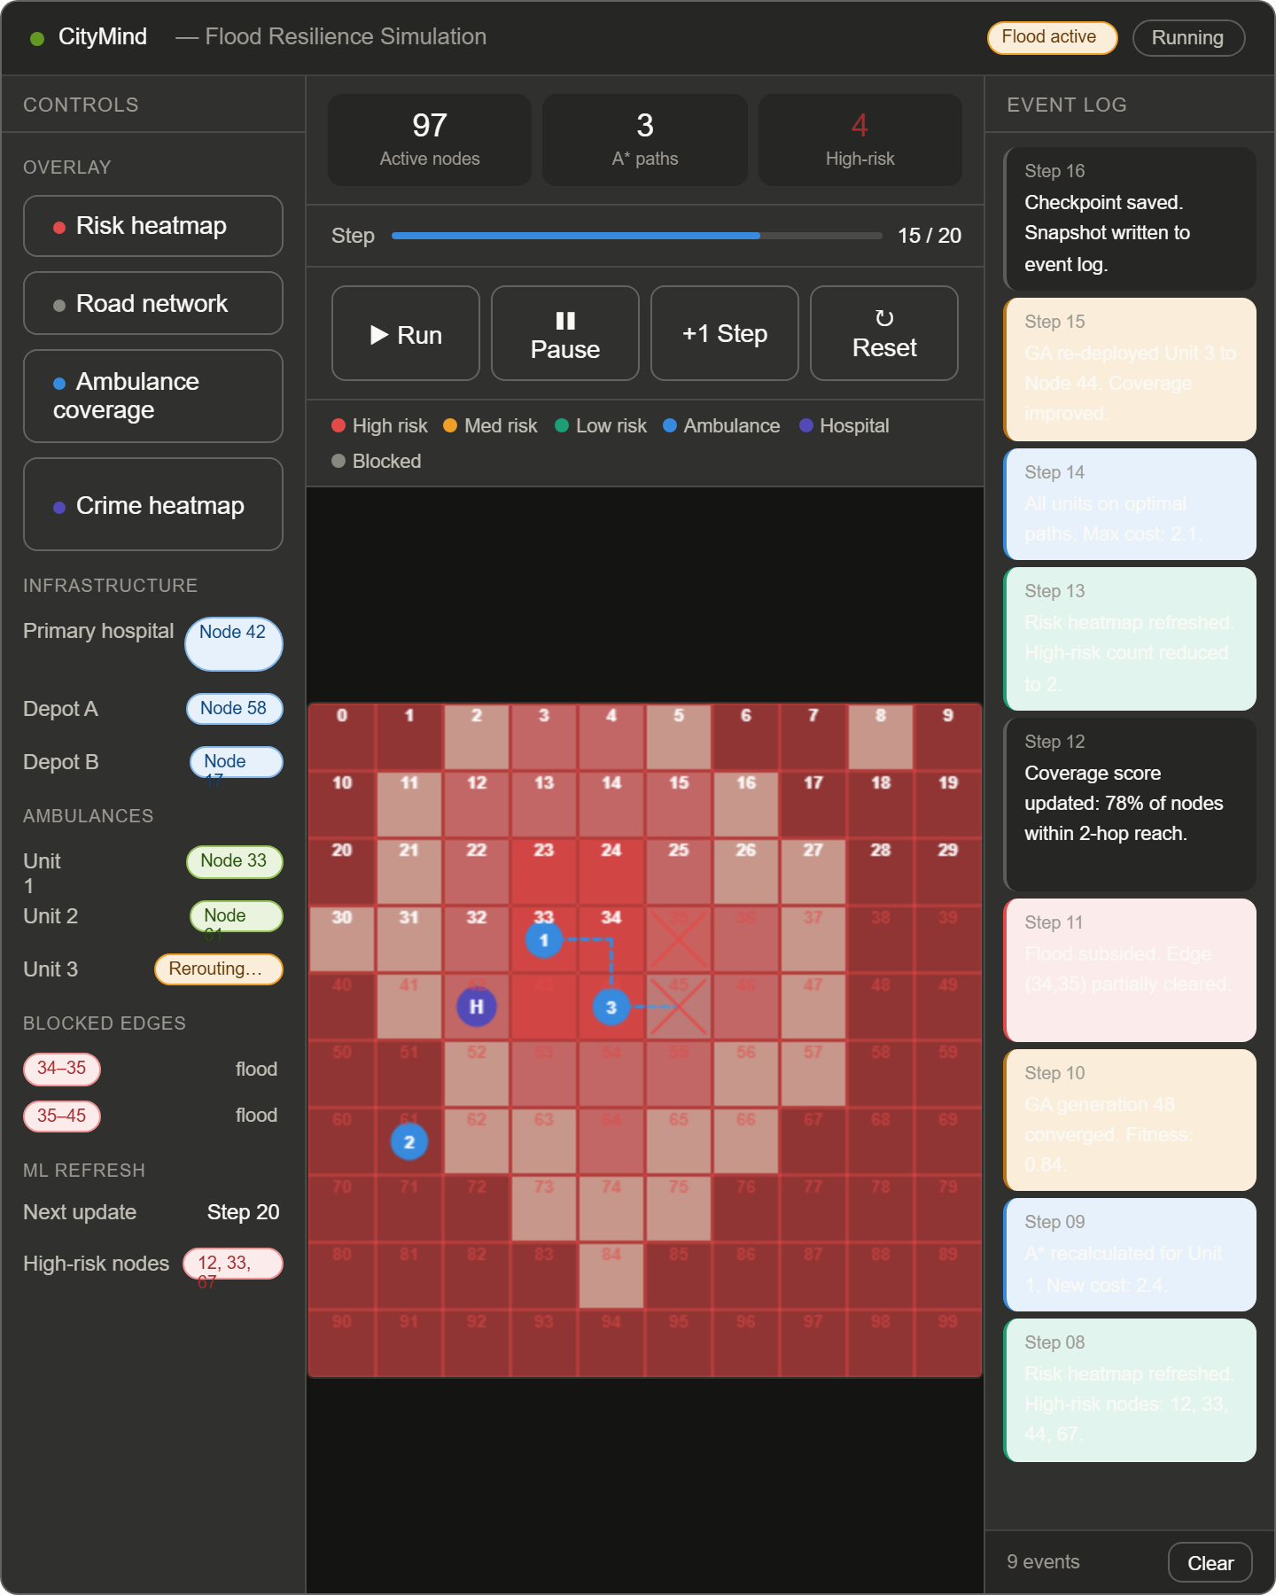

Work Breakdown Structure

Component | Primary Owner | Supporting Members
City Graph Data Structure + Integration | Zainab | All members
Challenge 1: CSP Layout Planner | Umaima | All members
Challenge 2: MST Road Optimizer | Sabia | All members
Challenge 3: GA Ambulance Placement | Sabia | All members
Challenge 4: A* Dynamic Router | Umaima | All members
Challenge 5: K-Means, Random Forest Classifier, Risk to graph | Zainab | All members
Pygame UI + Overlays | Whoever is available | AI
Event Log System | All members | -
20-Step Simulation Loop | All members | -
Phase 1 Design Document | All members | -
Viva Preparation | All members | -

12. Technology Stack & Language Justification
We have chosen Python 3.x as our primary implementation language. The justification is as follows:
- Familiarity: All three group members have the strongest proficiency in Python, reducing implementation risk.
- Library ecosystem: scikit-learn provides K-Means and Random Forest out of the box; NetworkX provides graph utilities; Pygame provides real-time grid rendering.
- Readability: Algorithm implementations in Python closely match pseudocode taught in class, making them easier to trace during the viva.
- Integration: All five modules and the shared graph can be imported as Python classes in a single codebase with no language-boundary overhead.

Library / Tool | Purpose
Python 3.11 | Primary language
NetworkX | Graph representation (used alongside our CityGraph class for utility functions)
scikit-learn | K-Means clustering, Random Forest classifier, cross-validation
Pygame 2.x | Real-time grid UI, overlay rendering, event log display
NumPy | Numerical operations, distance matrices, synthetic data generation
Matplotlib | Elbow curve for K-Means k selection (offline, not shown in UI)

